PERSONAL INFORMATION | Jasmina Gržinić
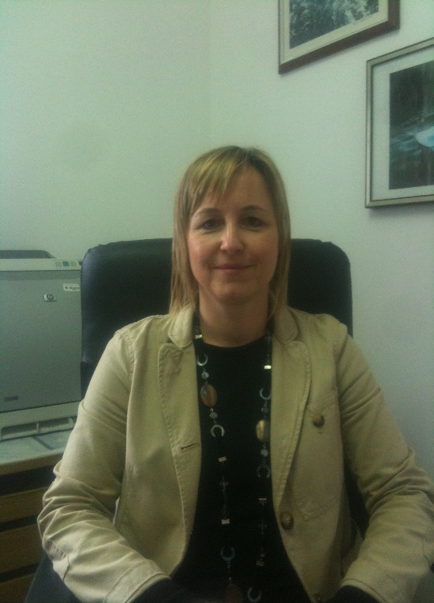 |   Preradovićeva 1, Pula, 52100, Republic of Croatia

tel. ++385/52 377 229  091 795 6454


jasmina.grzinic@unipu.hr; https://fet.unipu.hr/fet/jasmina.grzinic
https://www.bib.irb.hr/pregled/znanstvenici/259263?autor=259263
https://scholar.google.com/citations?hl=hr&user=m13cguwAAAAJ

 | Sex F | 31/05/1976| Croatian

WORK EXPERIENCE

2020 -  2014 - 2018  2012 - 2014  2008 - 2011  2006 - 2008  2001 – today | Member of the Scientific and Technological Institut Visio  University Jurja Dobrile in Pula  Member of the Committee on Science and Art  University Jurja Dobrile in Pula  Head of the Department of tourism  Faculty of Economics and Tourism “Dr. Mijo Mirković“ Pula, Croatia  Head of the Interdisciplinary academic program “Culture and tourism”  Faculty of Economics and Tourism “Dr. Mijo Mirković“  Author of the Lifelong learning program (tourism)  Faculty of Economics and Tourism “Dr. Mijo Mirković“  Academic Senate member  University Jurja Dobrile in Pula, Croatia  Assistant, Assistant prof., Associate prof., Full professor (field tourism)
  Faculty of Economics and Tourism “Dr. Mijo Mirković“,
  University Jurja Dobrile in Pula, Croatia

EDUCATION AND TRAINING

1994

2003

2006
1994  2003  2006 | Master of economics, Faculty of Economics in Pula, University of Rijeka  Graduate in Economics (mag.oec.)  University of Rijeka, Faculty of Tourism and Hotel Management (Opatija, Croatia)  PhD, University Jurja Dobrile in Pula

PERSONAL SKILLS

Mother tongue(s) | Croatian
Other language(s) | UNDERSTANDING |  | SPEAKING |  | WRITING
Other language(s) | Listening | Reading | Spoken interaction | Spoken production
Replace with language | C2 | C2 | C2 | C2 | C2
 | Replace with name of language certificate. Enter level if known.
Replace with language | A1 | A1 | A1 | A1 | A1
 | Replace with name of language certificate. Enter level if known.
Levels: A1/A2: Basic user - B1/B2: Independent user - C1/C2 Proficient user
Common European Framework of Reference for Languages

Communication skills | - adaptability to team work, good communication skills gained on active participation at international and domestic projects and conferences.

Organisational / managerial skills | Member of the numerous organizing Committees (international tourism conferences), a member of the editorial board of 5 international journals. Contributor to a total of 4 national scientific projects. Project manager of two university projects. Active participation in numerous expert projects for the benefit of the community (tour operators, agencies, museums, Istrian tourism board). Invited speaker at several international scientific conferences.

Job-related skills | Preparation of devalopment strategies for three Croatian destinations. Designing of doctoral study courses.  Membership in different domestic and international associations (International Economic Society IES, Association of Croatian Travel agencies (UHPA), Centre for European Research (CEIPU) and Juraj Dobrila University in Pula’s Student business incubator (SPIN), European Association of University Professors (EuAUP), American Association for Science and Technology (AASCIT), Balcan Economic Forum. Teacher training certificates from different scientific centers (Croatia, Slovenia).

Digital skills | SELF-ASSESSMENT
Digital skills | Information processing | Communication | Content creation | Safety | Problem solving
 | Proficient user | Proficient user | Proficient user | Proficient user | Proficient user
Levels: Basic user - Independent user - Proficient user
Digital competences - Self-assessment grid
 | - Skills in everyday MC OFFICE: word processor, spread sheet, presentation software.
Other skills | Improving professional competence related to tourism economy on two Interreg projects and by publishing 9 professional papers.  Mentor to students on professional projects at the home university as well as a representative in communication with hotel companies through the preparation for international competition purposes (Adria Hotel Forum, Zagreb 2018, 2019).  An active promotor of pedagogical competences at the University level (by publication and public lectures)

B
Driving licence

ADDITIONAL INFORMATION

Publishing of two scientific books and three university textbooks more than 100 scientific papers (articles). Scientific interest in the field of tourism intermediaries (touroperators and travel agents), management of tourism attractions and international tourism. Significant publications (in the last five years):

- Šergo, Z., Gržinić, J., Ilak Peršurić, A.S. (2021), „The effect of tourism overnights stays on Croatia's extra virgin olive oil prices and market power: An empirical study, INDECS Interdisciplinary Description of Complex Systems, 19 (4); 526-541 (Wos, EconLit).
- Šergo, Z., Gržinić, J. (2021), „The food import – International tourism nexus in Croatia: an application of the ARLD and NARDL approach and causality“, Economics of Agriculture, 26 (2): 275-290. (WoS).
- Gržinić, J. (2021), „Generation Y travel expectations and challenges for travel agents“, Interdisciplinary management research XVII, Balković, Dražen et al. (ed.), International conference, University Josipa Jurja Strossmayera u Osijeku, Faculty of Economics, Osijek i Pforzheim University, Business School, with Crotian Academy of Science and Art, p. 1018-1035. (WoS).
- Šergo, Z., Gržinić, J. (2019), Approach in tourism modelling, Collected papers, ur. Afrić Rakitovac, K., Kostić Bobanović, M., SCIENDO, de Gruyter. (WOS-CC expected).
- Gržinić, J., Kostić-Bobanović, M., (2019), Tourism education in an age of change, Scientific monograph, Juraj Dobrila University of Pula.
- Gržinić, J. (2018), „Removal of externalities in tourism by means of tour operator specialisation and education“, Economic review - Journal of economics and business, 16(2):75-86 (EconLit).
- Šergo, Z., Gržinić, J., (2018), „Does the international tourism industy relax sovereign credit ratings: The case od countries most reliant on tourism“, South East European Journal of Economics and Business. 13:2:100-111. ISSN 2233-1999. (WoS-CC).
- Šergo, Z., Gržinić, J., Ilak Peršurić, A.S., (2018), „The modeling of irrigation allocation in Croatia“, Tehnički vjesnik, 25(1):172-180. ISSN 1330-3651, DOI: 10.17559/TV-20160824133914. (SCI).
- Šergo, Z., Gržinić, J. (2017), „Exploring international tourism trends in the Mediterranean: Convergence or big divergence“, Journal of economic and social development (JESD), 4(1), pp.40-51 (EconLit).
- Šergo, Z., Gržinić, J., Sučić Čevra, M. (2017), The tourism and travel industry and its effect on the great recession: a multilevel survival analysis, Proceedings of Faculty of Economics, Rijeka, 35:2:427-458. DOI 10.18045/zbefri.2017.2.427 ISSN 1331-8004.1. (SSCI)
- Šergo, Z., Gržinić, J., Juraković, L. (2017), “Kaldor's Income Distribution and Tourism Specialization: Evidence from selected Countries”, Entrepreneurial Business and Economics Review, (EconLit)
- Gržinić, J., Šergo, Z., Floričić, T. (2017), Modelling wealth effect and demand for tourism departure in Europe: a panel data approach”, 19th International Scientific Conference on Economic and Social Development:proceedings / Kozina, Goran; Juznik Rotar, Laura; Tomić, Daniel (ur.). Varaždin; Melbourne; Warsaw: University North Croatia; Victoria Univesity Australia; University of Warsaw Poland, 399-409. (EconLit, Wos).
- Šergo, Z.; Gržinić, J., Saftić, D. (2015), “Modelling saturation intensity in the destination of Croatia: a panel data aproach”, 3rd International Scientific Conference Tourism in Southern and Eastern Europe (ToSEE), Sustainable Tourism, Economic Development and Quality Life: Conference Proceedings / Janković, Sandra ; Smolčić Jurdana, Dora (ur.). Opatija: Faculty of tourism and hospitality management, 383-397. (SSCI)
- Gržinić, J., Pavia, N., Floričić, T. (2014), „The perception of gastronomic events within the framework of sustainable tourism development“, Sustainable Tourism, International conference, Brebbia, C.A., S. Favro, S., F.D. Pineda, F.D. (ed.), Opatija, 8th to 10th July. p. 277 - 289. ISBN 978-1-84564-800-8, (Thomson Reuters CPCI).
- Gržinić, J., Vojnović, N., (2014), „Sustainable event tourism: Case study City of Pula, Croatia,“, UTMS Journal of Economics, (EconLit)
- Cultural tourism and destination impacts, (2015), međunarodna znanstvena monografija, Gržinić, J., Vodeb, K. (ur.), Juraj Dobrila University of Pula.

